EXHIBIT F
Website and Data Visualization Examples

Overview of Data Visualization Tools:
- DataViz Tools

Examples of Websites with Data Visualization (details below):

WASHINGTON

Washington State Health Care Authority (HCA)
- Analytics Research & Measurement (ARM) Data Dashboard Suite (Tableau)
- Healthier Washington Dashboard (Tableau)

Washington State Department of Health (DOH)
- Marijuana and Tobacco Use Dashboards (Tableau)
  - Behavioral Risk Factor Surveillance System (BRFSS)
- Opioid Awareness Dashboards (overdose and prescription data) (Tableau)
- Washington Tracking Network (WTN) (environmental public health data)

Results Washington (managed by WaTech)
- Improving Behavioral Health (PowerBI)
  - HYS: Youth Substance Use, Sad/Hopeless and Suicide Ideation
  - Healthier Washington Dashboard: Substance Use Treatment Penetration Rate for Medicaid Beneficiaries, Mental Health Treatment Penetration Rate for Medicaid Beneficiaries, Follow Up to ED Visits for Medicaid Patients for Mental Health Issue
- Preventing Substance Abuse and Improving Recovery (PowerBI)
  - DOH Death Certificates: Opioid-Related Deaths and Hospitalizations
  - HYS: Substance Uses by Types
  - OSPI: High School Graduation Rate

CALIFORNIA

UCLA Center for Population Health Research
- AskCHIS
  - California Health Interview Survey (CHIS)
- AskCHIS Neighborhood Edition
  - California Health Interview Survey (CHIS)

NATIONAL

Centers for Disease Control and Prevention (CDC)
- YRBSS Youth Online
  - Youth Risk Behavior Surveillance System (YRBSS)
  - YRBS Data Summary & Trends
    - Trends Report
    - Trends Fact Sheets
    - Infographics

Child and Adolescent Health Measurement Initiative
- Data Resource Center for Child & Adolescent Health
  - National Survey of Children’s Health
  - National Survey of Children with Special Health Care Needs

American Heart Association
- Center for Health Metrics and Evaluation
  - National Health and Nutrition Examination Surveys (NHANES)
  - National Youth Tobacco Survey

ARM Data Dashboard Suite
The ARM Data Dashboard Suite includes demographic makeup of the Medicaid population vs. overall Washington population, high-volume providers of specific health services to Medicaid clients, and metrics relevant to topics like opioid prescribing and chronic disease in the Medicaid population. As user needs evolve, this dashboard suite will continue to evolve to present timely and relevant information on populations of interest with a planned quarterly update of information. This information is complementary to the measures information on the Healthier Washington Measures Dashboard.
Healthier Washington Measures Dashboard
The Healthier Washington Measures Dashboard allows users to explore data on populations and measures for Washington State. The dashboards are updated or "refreshed" with data quarterly. The statewide measures for all populations and HEDIS quality measures for Medicaid population can be compared by region and trended by time.

AskCHIS
http://ask.chis.ucla.edu/
AskCHIS is an online health query system that allows you to quickly search for health statistics on your county, region, and state. AskCHIS draws upon the responses of more than 20,000 Californians interviewed each year by The California Health Interview Survey (CHIS) - the largest state health survey in the United States.
AskCHIS is:
- Easy to use
- Quick
- Authoritative
- Free
You can see your results on-screen or export to an Excel file.
Thousands of health experts, policymakers, journalists, and ordinary people use AskCHIS to quickly get data for grant proposals, needs assessments, research, news reporting, and policy-making.

Query Categories:
- Geographic Area (state, counties, regions)
- Topic
- Compare Topics *optional
- Limit Population *optional
- Years
Data Display Options:
- Data (tables): Compare Geography, Adjust Layout
- Charts: Bar or Pie
- Trends
Export Options:
- Email Results
- Export (Excel file)
- Print

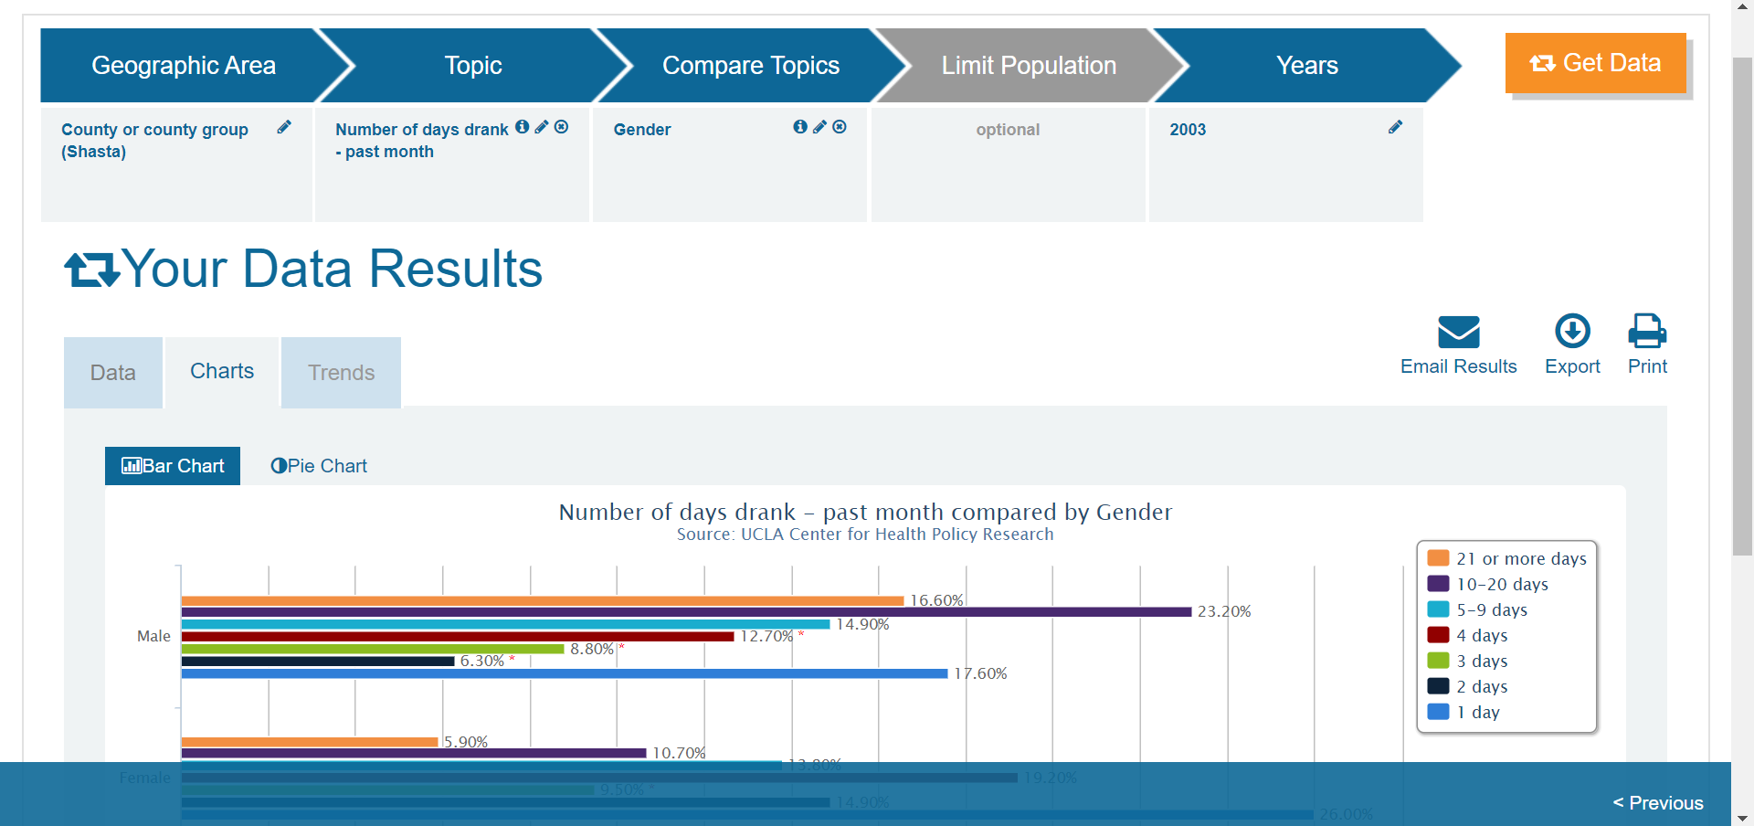

AskCHIS Neighborhood Edition
http://askchisne.ucla.edu/ask/_layouts/ne/dashboard.aspx#/
AskCHIS Neighborhood Edition is an online data dissemination and visualization platform that provides health estimates at sub-county geographic regions. With AskCHIS NE, you can access and visualize authoritative health data at zip code, city, county, and legislative district levels.
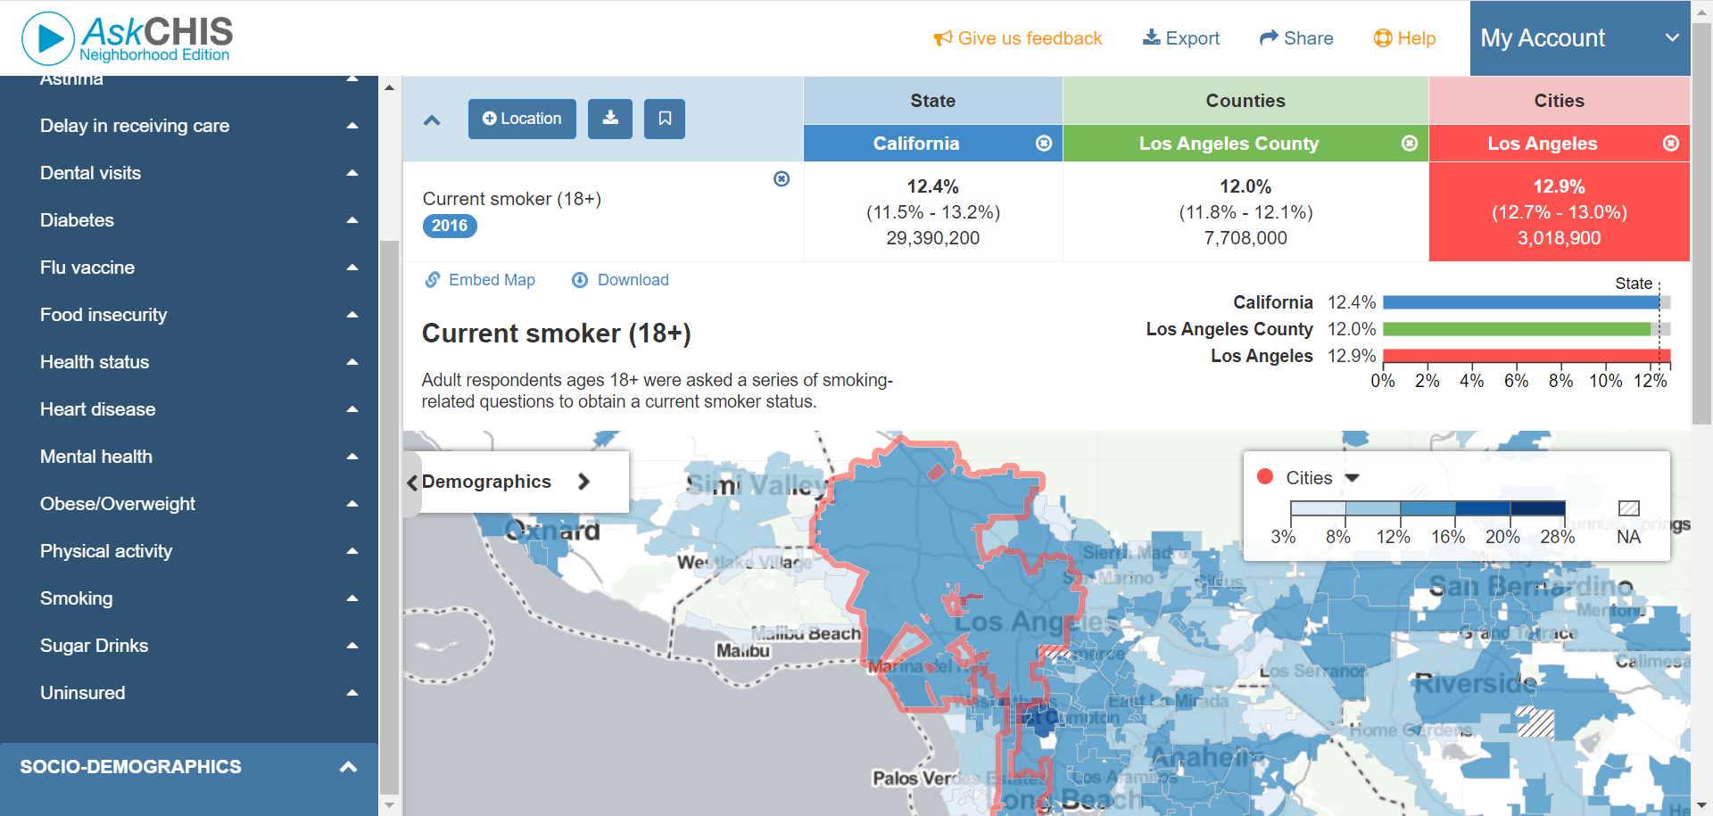

Data Resource Center for Child & Adolescent Health
https://www.childhealthdata.org/about-us/DRC
The DRC provides point-and-click online access to national, state, and regional findings from the National Survey of Children’s Health and the National Survey of Children with Special Health Care Needs. To assist in the use of this data, the DRC provides several user-friendly data resources, including:
- An interactive data query for NSCH and NS-CSHCN data
- Downloadable datasets with accompanying codebooks that include measures, indicator labels and more
- US maps to compare state data with national data
- Tables to compare data across states
Data are collected from parents and thus contribute a much-needed voice in the drive to improve health system performance for children, youth and families. Parent involvement in children’s health is critical, including their perspective on their child’s health and their interactions with the health system and community in which they live.
Query Steps:
- Select a survey, year, and geographic area
- Select a starting point/topic
- Select a survey question (includes all indicators with definitions)
Edit Search Criteria Options:
- Select a state or region to compare
- Subgroups
Really nice health measures chart that includes a visual of all indicators in the survey: https://www.childhealthdata.org/App_Themes/Main/Contents/nsch/content-map/2018-nsch-content-map_child-and-family-health-measures_08-30-19.pdf
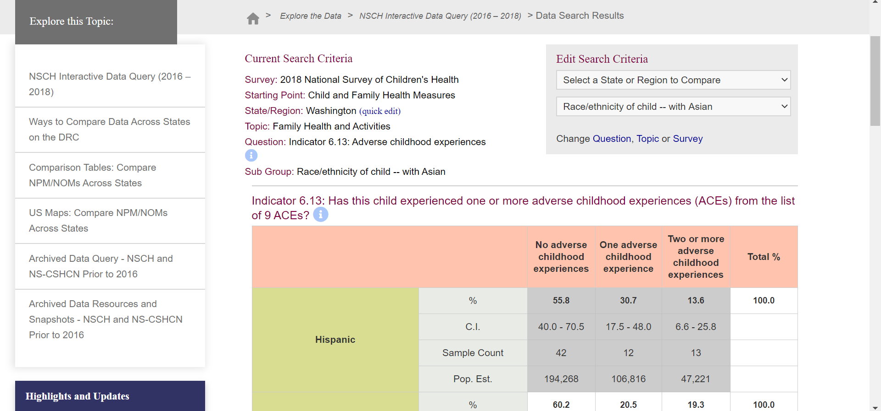

YRBS Online Results
https://nccd.cdc.gov/Youthonline/App/Results.aspx?TT=A&OUT=0&SID=HS&QID=QQ&LID=XX&YID=2017&LID2=&YID2=&COL=S&ROW1=N&ROW2=N&HT=QQ&LCT=LL&FS=S1&FR=R1&FG=G1&FA=A1&FI=I1&FP=P1&FSL=S1&FRL=R1&FGL=G1&FAL=A1&FIL=I1&FPL=P1&PV=&TST=False&C1=&C2=&QP=G&DP=1&VA=CI&CS=Y&SYID=&EYID=&SC=DEFAULT&SO=ASC

The YRBS results website presents all YRBS data in either table, graph, or map form. Data can be queried and compared in many different ways.

Table and Graph Options
Choose Table Content:
- Question
- Location (can view two locations or two years for one location)
- Year (can view all years in one table)
Data Filters:
- Health Topics
- Race/Ethnicity
- Grade
- Sexual Orientation
View Data by Subgroup (Column Variable) *can also compare column variables within table
- Totals Only
- Sex
- Race
- Grade
- Sexual Orientation
Display Options:
- Question Direction: Greater Risk, Less Risk
- Decimal Place: 0, 1, 2
- Variance: 95% CI, Standard Error, None
- Display Cell Size: Yes, No
Export Options:
- Get Link
- Print Table
- Export to Excel
Social Media Options:
- Facebook
- Twitter
- More (LinkedIn, Email, Digg, Add this to your site)

