June 22, 2022

Re: Letter of Advertisement – Fort Casey State Park – Inner Harbor Repair and Replacement – NW-3U413

Dear Sir/Madam:

Please publish the following legal advertisement under your “Advertisement for Bid” section for two (2) consecutive days beginning on June 23, 2022, or at your earliest possible convenience. An Affidavit of Publication will be required by this office. A voucher form is enclosed for your convenience in billing.

ADVERTISEMENT FOR BID

Sealed proposals will be received for the following project:

Fort Casey State Park – Inner Harbor Repair and Replacement – NW-3U413

PROJECT DESCRIPTION: | This project includes repair and replacement of the damaged breakwater, float system, and restoration of the shoreline along the Inner (Keystone) Harbor.
PROJECT LOCATION: | Fort Casey State Park is located at 1280 Engle Road Coupeville, WA, in Island County
ESTIMATED BID RANGE: | $2,500,000 - $3,000,000
BID OPENING TIME: | 1:00PM, Thursday, July 14, 2022
PREBID WALKTHROUGH: | 11:00AM, Thursday, June 30, 2022. Meet at the Fort Casey State Park Boat Launch Parking Lot, across the street from Callen’s Restaurant at 12981 SR20, Coupeville, WA

PLANS, SPECIFICATIONS, ADDENDA, AND PLAN HOLDERS LIST: Are available on-line through Builders Exchange of Washington, Inc. at http://www.bxwa.com. Click on: “bxwa.com”; “Posted Projects”; “Public Works”, “Washington State Parks & Recreation”, and “07/14/2022”. (Note: Bidders are encouraged to “Register as a Bidder”, in order to receive automatic email notification of future addenda and to be placed on the “Bidders List”. This service is provided free of charge to Prime Bidders, Subcontractors, and Vendors bidding this project.)
PLANS MAY ALSO BE VIEWED THROUGH: Builders Exchange, Everett WA; Daily Journal of Commerce, Seattle WA; Weekly Construction Reporter, Bellingham WA; Daily Journal Of Commerce Plan Center, Portland OR; Southwest Washington Contractors Association, Vancouver WA; Lower Columbia Contractor Plan Center, Longview WA; Inland Northwest AGC Plan Center, Spokane, WA; Abadon Reprographics, Spokane, WA; McGraw Hill Plan Center, Spokane, WA; Contractor Plan Center, Milwaukie, OR; Ridgeline Graphics, Wenatchee, WA; Spokane Regional Plan Center, Spokane, WA; Walla Walla Valley Plan Center, Yakima, WA.

Technical questions regarding this project shall be directed to Brian Keenan, Construction Project Coordinator at Brian.Keenan@parks.wa.gov.

Bidder Responsibility will be evaluated for this project. In determining bidder responsibility, the Owner shall consider an overall accounting of the criteria set forth in Division 00 – Instructions To Bidders. Please direct questions regarding this subject to the office of the Construction Project Coordinator.

This project is funded through a FEMA grant.

Voluntary numerical MWBE goals of 10% MBE and 6% WBE have been established for this project. Achievement of the goals is encouraged. Bidders may contact the Office of Minority and Women's Business Enterprise to obtain information on certified firms.

Mandatory 15% apprentice labor hours of the total labor hours are a requirement of this construction contract. Voluntary workforce diversity goals for this apprentice participation are identified in the Instructions to Bidders. Bidders may contact the Department of Labor & Industries, Apprenticeship Section, to obtain information on available apprenticeship programs.

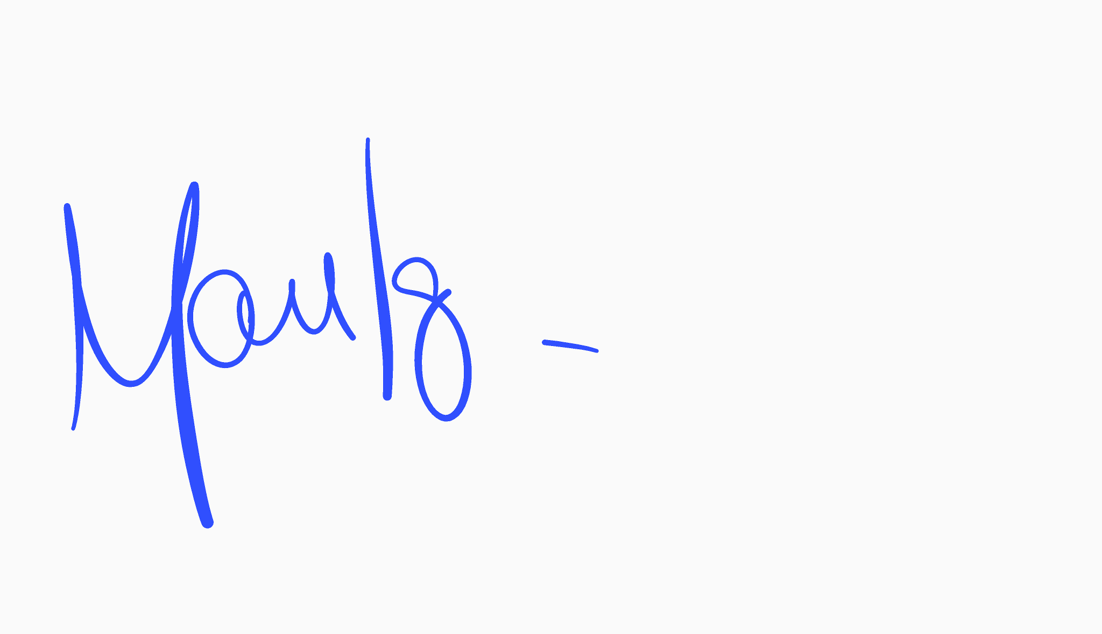Washington State Parks reserves the right to accept or reject any or all proposals and to waive informalities.

Sincerely,

Manuel Iglesias, Contracts Specialist
Contracts, Grants & Procurement Services

MI/jtj

cc: Darrel Hopkins, Acting NW Region Manager
Kyle Murphy, Capital Program Manager
Brian Keenan, Project Representative
Brett Bayne, Park Manager
Jon Holmes, Emergency Management Division (via e-mail)
OWMBE (via e-mail)

