PROJECT LOCATION – Exhibit A
Public Works Board Broadband Application 2021
Port of Garfield

This project will be located Northeast of Pomeroy, WA in Garfield County. Pomeroy's zip code is 99347. The project is expected to be along roads like Kirby Mayview Road, Bell Plain Road, Gould City-Mayview Road, E Lynn Road, Tramway Road, etc.

See below a map of the proposed area with the longitude/latitude of a few service locations.
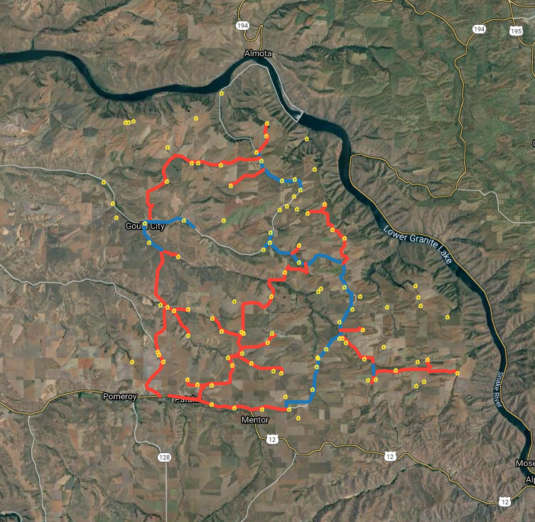
46.49850356922465,
-117.5609390057699
46.490727084886295,
-117.27636224331505
46.6557006706141,
-117.46243769040524
ALMOTA
POMEROY
N

