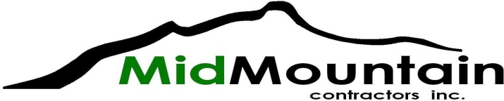

**SUBCONTRACTOR/VENDOR BID REQUEST**

**Project: SCWQP – Wallingford Conveyance**

**Owner: Seattle Public Utilities**

**Bid Date:** 6/15/22

**Bid Time:** 2:00 PM (all quotes required at least 3 hours prior to bid time)

**Documents:**

[https://seattle.procureware.com/](http:// www.bxwa.com)

**Trades: Asphalt Paving**

**Demolition**

**Drilling**

**Electrical**

**Erosion Control**

**Landscaping**

**Pavement Markings**

**Sawcutting**

**Settlement Monitoring**

**Shoring**

**Survey**

**Vibration Monitoring**

**Wet Utilities**

**Supply: Aggregates**

**TESC Materials**

**Pipe and Precast Structures**

**Contact:** Bill James (425) 202-3600; [Bjames@midmtn.com](mailto:Bjames@midmtn.com)

**Fax:** 425-202-3610

**MWDBE:** MidMountain Contractors is an equal opportunity employer and encourage small, women, minority, veteran, disabled veteran, and disadvantaged businesses to submit proposals

**Social Equity:** This contract includes a Community Workforce Agreement and Apprentice Utilization Goals. These are required and all subcontractors will participate. See the project’s General Conditions Specifications for further details.