September 3, 2021

Re: Letter of Advertisement – Nisqually State Park – Maintenance Building Phase 1

Dear Sir/Madam:

Please publish the following legal advertisement under your “Advertisement for Bid” section for two (2) consecutive days beginning Friday, September 3, 2021, or at your earliest possible convenience. An Affidavit of Publication will be required by this office. The required invoice voucher form to use for your billing is enclosed for your convenience.
ADVERTISEMENT FOR BID

Electronic proposals will be received for the following project:

Nisqually State Park – Maintenance Building Phase 1

PROJECT DESCRIPTION: | This project includes site preparation, erosion control, excavation, crushed aggregates, concrete pavements, one pre-engineered maintenance building, electrical site improvements, fencing and slide gate, cast-in-place concrete, asphalt paving, catch basins and subsurface drainage, topsoil, restoration plantings, and miscellaneous site improvements.
PROJECT LOCATION: | The project is located off of State Route 7, near Eatonville, WA. The project’s site address is: 43371 Mashel Prairie Road, E, Eatonville, WA, 98328.
ESTIMATED BID RANGE: | $705,000 – $790,000
BID DUE DATE: | 1:00PM TUESDAY, SEPTEMBER 28, 2021
PREBID WALKTHROUGH: | 10:00AM Thursday, September 16, 2021. Meet at the gate at the project location.

PLANS, SPECIFICATIONS, ADDENDA, AND PLAN HOLDERS LIST: Are available on-line through Builders Exchange of Washington, Inc. at http://www.bxwa.com. Click on “bxwa.com”; “Posted Projects”; “Public Works”, “Washington State Parks & Recreation”, and “09/28/2021”. (Note: Bidders are encouraged to “Register as a Bidder”, in order to receive automatic email notification of future addenda and to be placed on the “Bidders List”. This service is provided free of charge to Prime Bidders, Subcontractors, & Vendors bidding this project.)
PLANS MAY ALSO BE VIEWED THROUGH: Builders Exchange, Everett WA; Associated Builders And Contractors, Spokane WA; Tri City Construction Council, Kennewick WA; Daily Journal of Commerce, Seattle WA; Weekly Construction Reporter, Bellingham WA; Daily Journal Of Commerce Plan Center, Portland OR; Southwest Washington Contractors Association, Vancouver WA; Lower Columbia Contractor Plan Center, Longview WA; Inland Northwest AGC Plan Center, Spokane, WA; Abadon Reprographics, Spokane, WA; Hermiston Plan Center, Hermiston, OR; Idaho AGC, Boise, ID; McGraw Hill Plan Center, Spokane, WA; Oregon Contractor Plan Center, Milwaukee, OR; Ridgeline Graphics, Wenatchee, WA; Spokane Regional Plan Center, Spokane, WA; Walla Walla Valley Plan Center, Yakima, WA; The Blue Book Building and Construction Network, Jefferson Valley, NY.

Technical questions regarding this project must be directed to Bob Droll, Project Representative at Robert W. Droll, Landscape Architect, PS, 4405 7th Avenue SE, Lacey, WA 98503. Phone: (360) 456-3813, e-mail: bob@rwdroll.com

Bidder Responsibility will be evaluated for this project. In determining bidder responsibility, the Owner shall consider an overall accounting of the criteria set forth in Division 00 – Instructions To Bidders. Please direct questions regarding this subject to the office of the Engineer.

Voluntary numerical MWBE goals of 10% MBE and 6% WBE have been established for this project. Achievement of these goals is encouraged. Bidders may contact the Office of Minority and Women's Business Enterprise to obtain information on certified firms.

Mandatory 15% apprentice labor hours of the total labor hours are a requirement of this construction contract. Voluntary workforce diversity goals for this apprentice participation are identified in the Instructions to Bidders. Bidders may contact the Department of Labor & Industries, Apprenticeship Section, to obtain information on available apprenticeship programs.

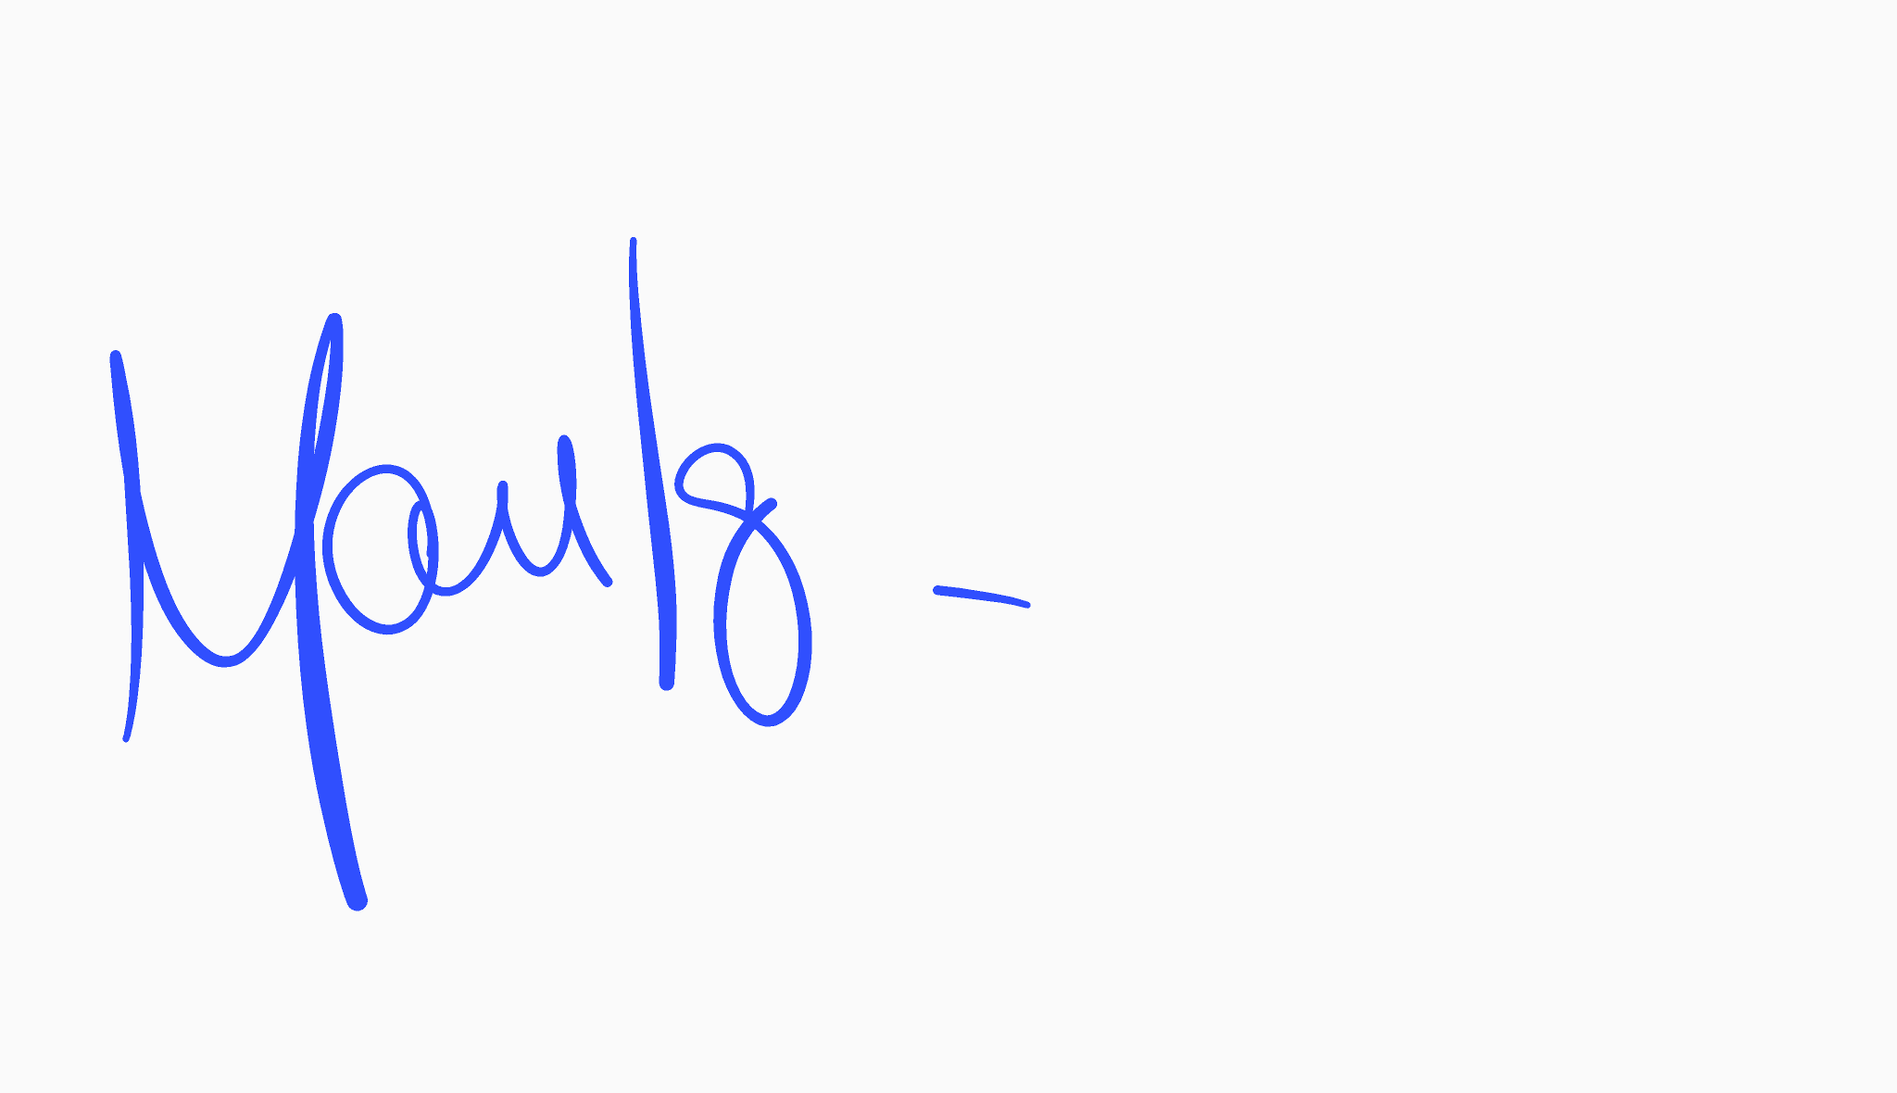Washington State Parks reserves the right to accept or reject any or all proposals and to waive informalities.

Sincerely,

Manuel Iglesias, Contracts Specialist
Contracts, Grants & Procurement Services

MI

cc: Matt Niles, Region Manager
Janet Shonk, Area Manager
Brian Yearout, Construction Project Coordinator
Bob Droll, Project Representative
Park Manager
OWMBE (via e-mail)

