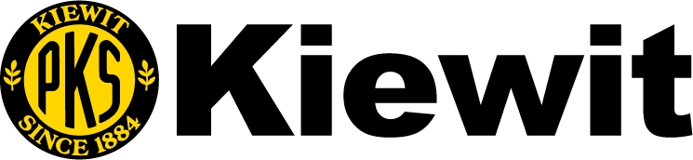
Kiewit is soliciting subcontractor bids and material quotes from subcontractors, service providers and suppliers, including Disadvantaged Business Enterprises (DBE) as certified by the Washington State Office of Minority and Women’s Business Enterprises (OMWBE) for the following project:
SR 305 / Bainbridge Ferry Terminal – OHL Walkway Replacement & Cab Rehab
Owner: Washington State Department of Transportation – Contract No. 9737
WSDOT Bid Date: December 1, 2021 @ 11:00 AM (PDT)

Scope Letter to Kiewit by: November 12, 2021 @ 4:00 PM (PDT)
Quotes Due to Kiewit by: November 19, 2021 @ 4:00 PM (PDT)
CONTACT:
Tom Jirava or Adam Eraky (253) 943-4200
KIEWIT INFRASTRUCTURE WEST CO.
33455 6th Ave South
Federal Way, WA 98003
DBE Questions: to dennis.ahl@kiewit.com
Dennis Ahl, Diversity Program Coordinator – Direct Phone (253) 943-4070
Bainbridge Ferry Terminal OHL Walkway Plans & specs accessed from the WSDOT website at:
https://www.wsdot.wa.gov/biz/contaa/Contracts/BainbridgeOHL.html
Kiewit Infrastructure West Co. is seeking quotes from Subcontractors and Suppliers including Small and Disadvantaged Business Enterprises (DBE’s), as certified by Washington State’s Office of Minority and Women Business Enterprises (OMWBE). The condition of award goal is for 16% DBE participation. Kiewit will provide the maximum practicable opportunity to the DBE subcontracting community to compete for and participate in subcontracts let by Kiewit for this project
Project has Ferry Terminal, Highway & Bridge Construction Subcontracting Opportunities including: Aggregate (Furnish) Asphalt Paving, Architectural CAB, Balcony Swinging Gates, Barrier Delineators, Bubble Curtain, Concrete Redi-mix, Demolition (Abatement/Disposal), Disc Bearings, Divers, Environmental Services (Erosion Control, Forage Fish Survey, Monitor Protected Species), Electrical, Expansion Joints, FRP Decking, Fire Protection, Glazing & Door Assemblies, Hose Bib Piping, Metal Roofing & Flashing, Overhead Loading (OHL Misc Steel, OHL Lifting & Hyd System) Painting, Temp. Pedestrian Bridge, Piling (Steel), Pile Testing, Reinforcing Steel, Roof Overhang (Temp) Security, Saw cutting, Striping, Structural Steel, Survey, Traffic Barriers, Traffic Control, Walkway Flashing & Handrails, Wire sawing, and other work scopes.
In order to assist certified Disadvantaged Business Enterprise (DBE) Subcontractors, Service Providers and Suppliers, we will divide items of work into smaller economically feasible units; smaller tasks or quantities; and establish delivery/construction schedules which will allow maximum DBE participation where feasible. Subcontractors are required to execute Kiewit standard Subcontract or Material Contract agreements.
We are an Equal Opportunity Employer

