SUB-BIDS REQUESTED

**3rd Ave West Water Main Replacement**

# Bid Due: 7/18/18; 2:00 PM

# Quotes Due: 7/18/18; 1:00 PM

Project includes: Surveying; Sawcutting; Concrete Coring; General Demolition; Sewer Cleaning; Landscaping; Trucking; Mechanical Piping; Concrete Construction including Rebar & Concrete; Fabricated Metals & Installation; Excavation & Yard Piping; Cathodic Protection; Traffic Control, Electrical.

Accepting bids for all trades.

**MWBE Goal: 18%**

Stellar J intends to negotiate in good faith with all certified MBE/WBE firms to encourage participation, including tailoring packages to better fit these firms’ capabilities. Please contact us regarding assistance with obtaining bonding, insurance requirements, and other needs.

Plans and Specifications are available online at [**www.stellarj.com**](http://www.stellarj.com/)

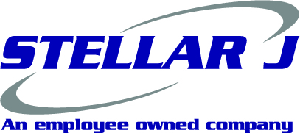

STELLAR J CORPORATION

1363 Down River Drive • Woodland, WA 98674

**Phone: (360) 225-7996 Bid Fax: (360) 225-8007**

**Email: bids@stellarj.com**

CCB# 127903 WA#STELLJC045J9

We are an equal opportunity employer and request sub-bids from all subcontractors and suppliers including SCS, Minority, Women, Disadvantaged and Emerging Small Business Enterprises

Assistance is available with schedule and scope size for MWESB firms.