Content: Outreach Model Framework Plan Audience: Agency Leadership and Outreach Team

A Successful Procurement Outreach Plan is…
Definitions
Have clear definitions in your document to ensure shared understanding and clarity of expectations. Below are a few examples:
- Good faith effort – The expected minimum an agency would do for outreach.
- Outreach – The act of communicating and building relationships with the community.
- Diverse Business – A business that has the potential to obtain Washington State certification with the DVA or OMWBE or is a self-certified small business.
- Contractor- A business with primary contract responsibility.
- Subcontractor- A business that is subordinate to the primary contractor (with or without flow down responsibility).
- Inclusion Plan- A detailed plan showing the good faith efforts the business will make toward the Governor’s Results Washington Inclusion Goals for Diverse Businesses. As outlined in RCW 39.26.010, Minority and Women Business Enterprises (MWBEs) as defined in RCW 39.39.19 and WAC 326-20, and Veteran-owned businesses as defined in RCW 43.60A.010. An Inclusion Plan reflects a vendor, contractor, or consultant’s commitment to demonstrate a comprehensive “Outreach Strategy” that will engage and identify availability of Diverse Businesses that are ready, willing, and able to take on the work.
- Central Point of Contact – Contact authorized to share information regarding the outreach plan and any relevant solicitations.
- Schedule – Calendar of critical dates associated with procurement participation.
Purpose Driven
Be clear on the purpose of your plan. An example purpose statement is:

What is the purpose?
“The purpose of the Diversity & Inclusion (D&I) Procurement Outreach Plan is to:
• Establish a framework within the Procurement Process for the fair consideration and inclusion of Diverse Businesses;
• Guide the evaluation and management of Supplier Diverse Business & Inclusion commitments during the Procurement Process; and
• Support the Governor’s inclusion goals (__% minority; __% women; __% veteran).

Inclusion Focused
Your plan should bring awareness of the valuable impact of being inclusion focused, helping the reader understand what outreach is, why we do it and what the risks are if we don’t do it. Here is some sample language:

What is outreach? Outreach is not just a checklist or stakeholder distribution list. It is an active and engaging effort to connect with potential contractors and others impacted by procurement and contracting efforts and outcomes. It is strategic, leverages resources and leads to better outcomes when done correctly and authentically. It is:
- The seeking and/or developing participation from, and inclusion of under-represented or under-utilized suppliers.
- Purposeful communication to make a connection with potential diverse businesses and promote opportunities for supplier diverse businesses.
- An intentional analysis and inventory of the sources, firms and partnerships.
- The development of pathways to make the connections by building community relationships.
- Understand corporate requirements for business partnership (i.e. minimum sales volume) in order to understand corporate flexibility for Washington State inclusion.

Why we do it? Outreach practices should reflect our population’s demographic and be responsive to the communities’ demographic changes. Doing so:
- Plays an integral part of economic health to state; diverse businesses represent economic vitality.
- Supports the state’s economic development plans and goals which do not represent the current opportunity in the State of Washington.
- Makes new businesses aware of business opportunities with the state.
- Meets legal requirement for non-discrimination.
- Confirm cooperative maintenance of Diverse Business Status (i.e. certification status current).
- Meets the legislative intent for the state to develop procurement policies, procedures and materials that encourage and facilitate state agency purchase of goods and services from Washington small businesses.
- Helps us improve disparity study findings.

What are risks of not doing it? By not conducting consistent and comprehensive outreach, purchasers of goods and services:
- Decreased competition and increased cost in state contracts
- Lost innovation and creativity in the supply of goods and services
- Miss the opportunity to have a positive impact on the viability of diverse businesses and the state’s economy
- Lack alignment with intention of the Legislature and Governor
- Fail to qualify and include new businesses to meet these needs. The business population in the State of Washington is dynamic and growing tremendously so the State needs to continually.

Engagement Centered
Your policy should contain language that explains how your organization will conduct outreach as well as define clear roles and responsibilities. Here are links to Washington State Department of Transportation’s Inclusion Plan and Engagement Principles.

Conduct Outreach:
- Conduct outreach in partnership with other state agencies, nonprofits and other organizations
- Identify outreach gaps with ethnic and gender communities that may have not been engaged recently or at all.
- Identify the community outreach schedule (i.e. what is already available?)
- Identify what schedule aligns with agency message and target markets
- Post-outreach follow up and positioning for ongoing or future state business opportunities.

Roles and responsibilities:
Have clear roles and responsibilities for your outreach team. Below are some examples:

Agency Heads
The Director is the custodian of the Diverse Business expectations set by the Governor and the laws of the State of Washington. Any changes to Diverse Business expectations must be approved by the agency Director. In the absence of the Agency Director, this responsibility rests with the next senior level of authority, or his or her designee.

Category Owner
The Category Owner works in concert with the Diverse Business initiative owner who establishes requirements for meeting the agency’s Diverse Business plan, and may also coordinate, evaluate and monitor inclusion plans. The Category Owner is responsible for the purchasing activity for the agency. For example, the purchase of office supplies, information technology, real estate or administrative consultants, whether for the agency, division or facility.

Coordinator, Supply Chain Diversity & Inclusion
The Coordinator, Supply Chain Diversity & Inclusion is a liaison between internal stakeholders and external stakeholders for the execution of outreach activities to invite and qualify Diverse Business for the needs of the Agency and Category Manager. This individual may provide technical assistance and guidance related to Diversity & Inclusion within the Agency’s Procurement Outreach Process.

Outreach Outcome Accountability

Accountability
To be accountable, it is important for Agency’s to invest in the community by being responsible for the outcome. Investing requires the State Agency to:
- Build Trust.
- Prepare small businesses to navigate through government.
- Connect the business to an opportunity.
- Clearly demonstrate partnerships for opportunity.

Measurement
State agency
- Create and define outcome measures and how they will be shared transparently
- Outreach staff should complete available training (i.e. cultural training)
- Consult with stakeholders consistently to obtain feedback (i.e. surveys)

Continuous Improvement
Outreach plan should describe your internal processes for ensuring a culture of quality assurance and improvement.
- Assess feedback gathered and applied to your procurement process (i.e. bid debrief feedback).
- Survey feedback with contractors and partners.
- Performance and process review (i.e.: outreach, certification, contract) Refer back to “Measurements” section above for how an agency may be measured.

Summary
Outreach plans are integral to your success in engaging Diverse Business in the contracting and procurement process. Following the steps discussed in this document will help you achieve your desired outcomes, while also promoting inclusion; making a difference in the lives of people in your community who are ready, willing and able to do the work you need done with high quality at a reasonable cost.

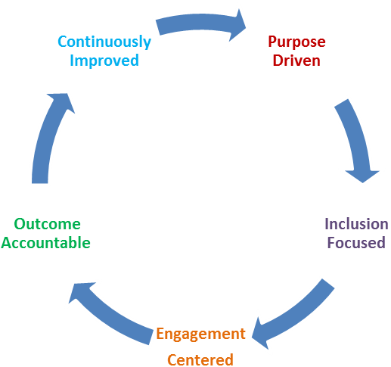
Outreach
Plan
Success!

RCW 39.26.005

