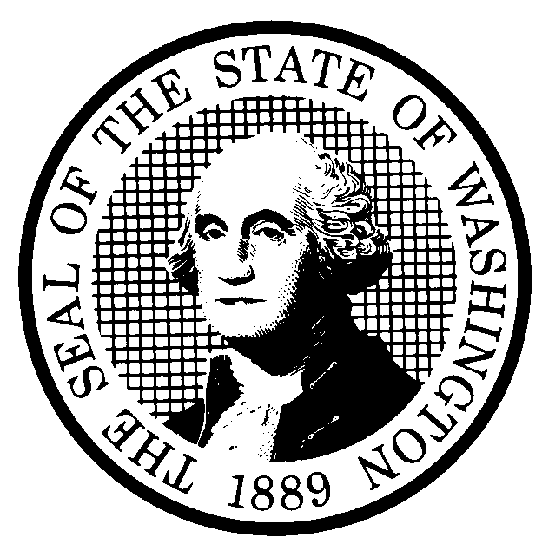 | RULE-MAKING ORDER  PERMANENT RULE ONLY |  |  |  |  | CODE REVISER USE ONLY
CR-103P (December 2017)
(Implements RCW 34.05.360)
Agency: OMWBE
Effective date of rule:
Permanent Rules
☒ 31 days after filing.
☐ Other (specify) (If less than 31 days after filing, a specific finding under RCW 34.05.380(3) is required and should be stated below)
Any other findings required by other provisions of law as precondition to adoption or effectiveness of rule?
☐ Yes ☒ No If Yes, explain:
Purpose: OMWBE proposes to amend WAC 326-20-048 to include LGBTQ individuals as socially disadvantage. This will provide rule clarity and assure qualifications, procedures and guidelines for determining eligibility for the LGBTQ Certification is aligned with OMWBE’s portfolio of programs insuring balance and equity.
OMWBE proposes to adopt WAC 326-20-088 to implement the LGBTQ certification program in accordance with SB5950.

Citation of rules affected by this order:
New: WAC 326-20-088
Repealed:
Amended: WAC 326-20-048
Suspended:
Statutory authority for adoption: RCW 39-19-030
Other authority: NONE
PERMANENT RULE (Including Expedited Rule Making)
Adopted under notice filed as WSR 25-09-102 on April 18, 2025 (date).
Describe any changes other than editing from proposed to adopted version:
If a preliminary cost-benefit analysis was prepared under RCW 34.05.328, a final cost-benefit analysis is available by contacting:
Name:
Address:
Phone:
Fax:
TTY:
Email:
Web site:
Other:
Note: If any category is left blank, it will be calculated as zero.
No descriptive text.

Count by whole WAC sections only, from the WAC number through the history note.
A section may be counted in more than one category.
The number of sections adopted in order to comply with:
Federal statute: |  |  | New |  | Amended |  |  | Repealed
Federal rules or standards: |  |  | New |  | Amended |  |  | Repealed
Recently enacted state statutes: |  |  | New |  | Amended |  |  | Repealed
The number of sections adopted at the request of a nongovernmental entity:
New |  |  |  |  | Amended |  |  | Repealed
The number of sections adopted on the agency’s own initiative:
New |  |  |  |  | Amended |  |  | Repealed
The number of sections adopted in order to clarify, streamline, or reform agency procedures:
New |  |  |  |  | Amended |  |  | Repealed
The number of sections adopted using:
Negotiated rule making: |  |  | New |  | Amended |  |  | Repealed
Pilot rule making: |  |  | New |  | Amended |  |  | Repealed
Other alternative rule making: |  |  | New |  | Amended |  |  | Repealed
Date Adopted: July 1, 2025  Name: Julie Bracken  Title: Public Records Officer, Records Manager, Rules Coordinator | Signature:

